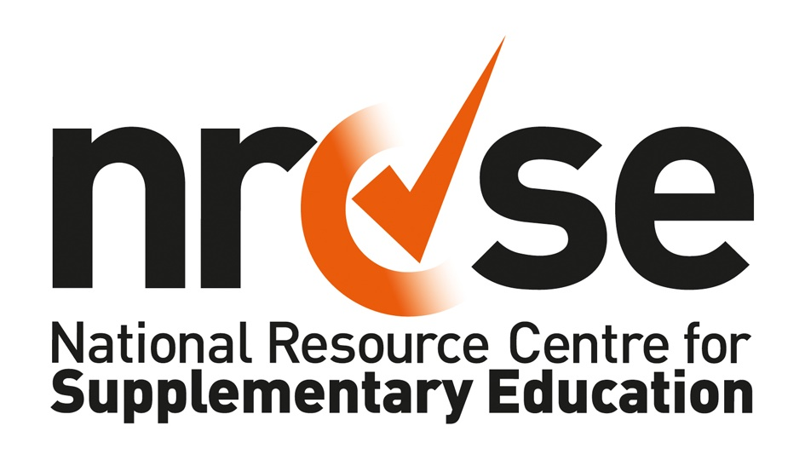
Job Description
Post Title: | Intern role within Quality Development Advice Team
Key Purpose: | To support supplementary schools within the London Borough(s) of Brent/Barnet/Camden/Ealing/Hammersmith & Fulham and Westminster in providing mentoring and guidance towards safeguarding and quality assurance, to forge effective relations between statutory and voluntary agencies and supplementary schools, to facilitate training for all parties, to ensure all parties are kept well informed, and to take responsibility for ensuring the success of the project.
Responsible to: | You will be line managed by the JLC Project Quality Development Adviser
Responsible for: | None
Salary:  Disclosure & barring requirement: | £10.55 per hour (London Living Wage) + benefits  Yes – enhanced
Expected time commitment: | 2.5 days (18 hrs) per week for 7 to 10 months  The work will require flexible hours, outside of usual office hours and regular weekend working.
Location: | The post will have desk space allocated within NRCSE London office at Resource for London, N7.  Travel within the boroughs will also be required (expenses will be covered)

Major Objectives
You will work as part of the Quality Development Advice Team. You will, in collaboration with and with the guidance of, other members of the Quality Development Team, provide a basic support and coordination service to supplementary schools within the boroughs including: mentoring towards quality assurance, signposting, brokering, advocacy and contributing toward existing initiatives supporting supplementary schools within each borough.
The principle goals are to support supplementary schools to complete the Good Management file and achieve their local authority’s S11 safeguarding requirements and move on to achieve the NRCSE Quality Mark for Supplementary Education. You will also be expected to forge strong working and learning relations between the supplementary schools involved in the project, the CVS, mainstream schools and Children’s Services and Safeguarding teams in the relevant boroughs.
This will require you to:
- Work closely with the existing staff members in the local authorities and CVSs whose work includes supporting community development, school improvement, ethnic minority achievement and targeted work to raise educational attainment among disadvantaged groups.
- Identify willing and committed partners within the supplementary schools sector;
- Research and fully understand the barriers to and opportunities presented by greater collaboration;
- Facilitate development and training sessions, to include the school curriculum, self-evaluation and capacity building;
- Work with supplementary schools to ensure they meet agreed basic safeguarding standards, including the proposed Safeguarding Code of Practice and DBS registration requirements, or are working to achieve them;
- Promote and facilitate the NRCSE Quality Mark and act as a mentor to supplementary schools preparing portfolios for recognition.
- In collaboration with NRCSE colleagues, support supplementary schools to identify educational experts in their area who are willing to act as Educational Experts for the Quality Mark recognition meetings.
- Ensure all parties are kept well informed;
- Work in collaboration with NRCSE colleagues, Young People Foundations, staff of the London Boroughs of Brent, Barnet, Camden, Ealing, Hammersmith & Fulham, Westminster including Children’s Services, LSCBs, Safeguarding as appropriate;
- The post-holder will, as required to:
  - be aware of, and adhere to, the provisions of Health & Safety, as detailed in the Health & Safety procedures, in particular those relating to lone workers.
  - uphold and reflect NRCSE's values and policies in respect of equality and diversity in all you do and say.
  - undertake such additional responsibilities as required, which are commensurate with the grade and responsibilities of the role.

Person Specification
Ideal skills, knowledge, experience and behaviours | Assessment
- Understanding and appreciation of issues and developments around both learning within BME and disadvantaged communities and supplementary education in the UK. | A, I, E
- Ability to work with diverse ethnic communities. | A, I
- Ability to support capacity development and quality assurance within BME and disadvantaged communities. | A, I
- Ability to work effectively and successfully with education managers and leaders. | A, I
- Knowledge of the National Curriculum and current educational practice. | A,I
- Demonstrate an awareness of barriers to learning | A,I
- Excellent organisational and administrative skills including ability to prioritise workload & to work under pressure. | A, I
- Excellent communication skills including ability to engage with, listen to and persuade a wide range of individuals and organisations (on the telephone, in meetings, etc.) and well-developed formal writing skills (for letters, reports, etc). | A, I, E
- Good IT skills including MS Word & Excel and use of email | A, E
- Ability to maintain & further develop a network of contacts within a broad range of organisations | A, I
- Ability to generate good will and commitment among those with whom you work | A, I
- Understanding of and commitment to diversity and equal opportunities. | A, I, E
- Enthusiasm for and commitment to NRCSE’s values. | A, I
- Self-starting - must be pro-active and flexible. | A, I
- Ability to travel around West London to visit schools, etc. | A, I
- Be able to work flexible hours, outside of usual office hours and weekend working. | A,I
- Successful completion of a Disclosure and Barring check. | Post-interview process

Key to Assessment
A = Application Form
I = Interview
E = Exercise or Presentation

